

EZ Connect™
Wireless High Gain Antennas

SMCANT-DI105
SMC’s Wireless High Gain 10.5 dBi Antenna is the ideal wireless networking solution for home and office environment. This high gain wide dispersion antenna is perfect for extending the operating distance of a wireless network without the high cost and limitations of wiring. This patent-pending antenna technology provides outstanding performance as well as great penetration of trees, structures, and other obstacles.

SMCANT-DI135
SMC’s Wireless High Gain 13.5 dBi Antenna is a universal antenna that can be used in a wireless LAN environment to provide greater structural penetration. It can also be used as a point-to-point antenna with an operating distance of up to 7 miles or for general-purpose point-to-multipoint applications.

SMCANT-DI145
SMC’s Wireless High Gain 14.5 dBi Antenna is the perfect choice for point-to-point application. This patent pending antenna does not require line-of-sight. It has unsurpassed structural penetration capability and its narrower beam and higher gain can achieve an operating distance of up to 9 miles.
Optional Accessories to install with SMC’s High Gain Antenna
SMCANT-DS
SMCANT-DS Antenna Desktop Stand is used in conjunction with SMC’s high gain antenna to secure the antenna in place for indoor use.

SMCANT-MA
SMCANT-MA Antenna Mounting Arm is used in conjunction with SMC’s high gain antenna to secure the antenna in place for outdoor use.

SMCANT-CAB25
This 25” LMR 195 Antenna Cable connects SMC’s Access Point/Bridge to an SMC High Gain Antenna.

SMCANT-CAB78
This 78” LMR 400 Antenna Cable is used for extending the distance between SMC’s Access Point/Bridge and an SMC High Gain Antenna.
Package Contents
After unpacking your SMC High Gain Antenna, check the contents of the box to be sure you have received the following:

- SMC High Gain Antenna
- This Quick Installation Guide

Please register this product and upgrade the product warranty at www.smc.com.

Desktop Stand
Assembly Instructions
- Place antenna mounting screw (2) through hole (6).
- Screw on lock washer (3) and hex nut (4), and tighten.
- Attach the cable to the connector (1) on the back of antenna.
- Attach the other end of the cable to wireless device.
- For optimal results, place the antenna tip (5) in the direction of desired coverage area.
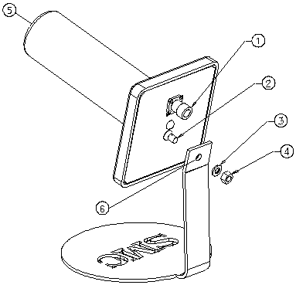

Component List:

- Cable Connector
- Antenna Mounting Screw
- Lock Washer
- Hex Nut
- Front of Antenna
- Desktop stand hole

Mounting Arm

Assembly Instructions
- Place antenna mounting screw (2) through the arm bracket hole (3) on arm bracket.
- Screw on lock washer (4) and hex nut (5), and tighten
- Attach the cable to the connector (6) on the back of antenna.
- Attach the other end of the cable to wireless device.
- For optimal results, place the antenna tip (1) in the direction of desired coverage area.
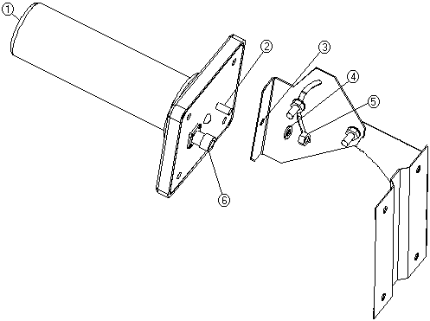

Component List:

- Front of Antenna
- Mounting Screw
- Mounting Hole
- Lock Washer
- Hex Nut
- Cable Connector

